
Trinity High School
Physics Department

Revised Higher
Unit 3 Electricity



Problem Booklet

Name……………………………………………… Class……………………
Exercise 1: Monitoring and measuring a.c.

1. (a) What is the peak voltage of the 230 V mains supply?
(b) The frequency of the mains supply is 50 Hz. How many times does the voltage fall to zero in 1 second?

2. The circuit below is used to compare a.c. and d.c. supplies.

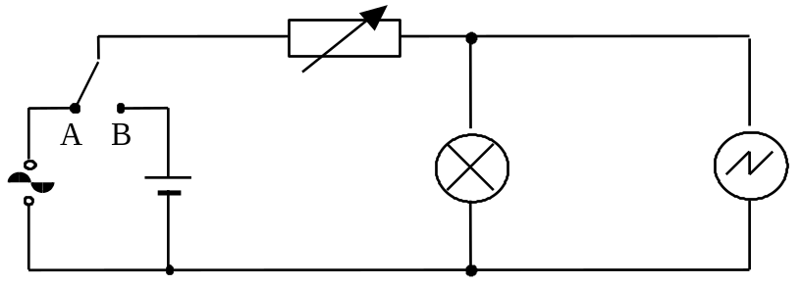

The variable resistor is used to adjust the brightness of the lamp until the lamp has the same brightness when connected to either supply.

(a) Explain why the brightness of the lamp changes when the setting on the variable resistor is altered.
(b) What additional apparatus would you use to ensure the brightness of the lamp is the same when connected to either supply?
(c) The time-base of the oscilloscope is switched off. Diagram 1 shows the oscilloscope trace obtained when the switch is in position B. Diagram 2 shows the oscilloscope trace obtained when the switch is in position A.

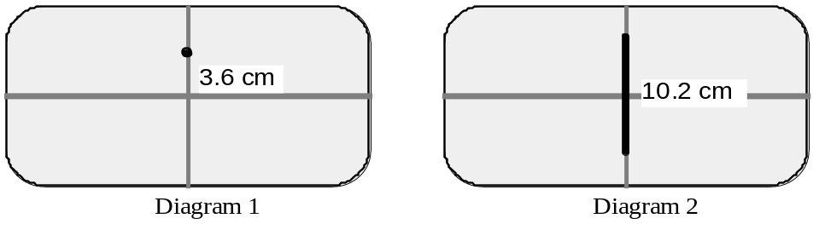
Y gain set to 1 V cm^{–1}

Using information from the oscilloscope traces, find the relationship between the root mean square (r.m.s.) voltage and the peak voltage of a voltage supply.

(d) The time-base of the oscilloscope is now switched on. Redraw diagrams 1 and 2 to show what happens to the traces.

3. The root mean square voltage produced by a low voltage power supply is 10 V.

(a) Calculate the peak voltage of the supply.
(b) An oscilloscope, with its time-base switched off, is connected across the supply. The Y-gain of the oscilloscope is set to 5 V cm^{–1}. Describe the trace seen on the oscilloscope screen.

4. (a) A transformer has a peak output voltage of 12 V.
Calculate the r.m.s. value of this voltage.
(b) An oscilloscope, with the time base switched off, is connected across another a.c. supply. The Y gain of the oscilloscope is set to 20 V cm^{–1}. A vertical line 6 cm high appears on the oscilloscope screen.

Calculate:
(i) the peak voltage of the input
(ii) the r.m.s. voltage of the input.

5. An oscilloscope is connected across a signal generator. The time-base switch is set at 2·5 ms cm^{–1}.
The diagram shows the trace on the oscilloscope screen.

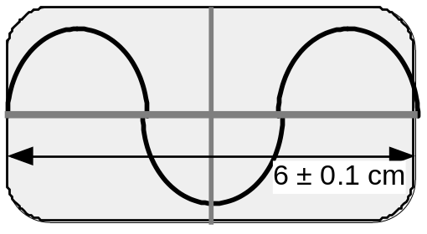

(a) (i) What is the frequency of the output from the signal generator?
(ii) What is the uncertainty in the frequency to the nearest Hz?
(b) The time base switch is now changed to:
(i) 5 ms cm^{–1}
(ii) 1·25 ms cm^{–1}.
Sketch the new traces seen on the screen.

6. An a.c. signal of frequency 20 Hz is connected to an oscilloscope. The time-base switch on the oscilloscope is set at 0.01 s cm^{–1}.
Calculate the distance between the neighbouring peaks of this waveform when viewed on the screen.

Exercise 2: Current, voltage, power and resistance

- There is a current of 40 mA in a lamp for 16 s.
Calculate the quantity of charge that passes any point in the circuit in this time.
- A flash of lightning lasts for 1 ms. The charge transferred between the cloud and the ground in this time is 5 C.
Calculate the value of the average current in this flash of lightning.
- The current in a circuit is 2 5 × 10^{–2} A. How long does it take for 500 C of charge to pass any given point in the circuit?
- There is a current of 3 mA in a 2 kΩ resistor. Calculate the p.d. across the resistor.
- Calculate the values of the readings on the meters in the following circuits.
A
10 V
+
–
70 Ω
10 Ω
20 Ω
(a)
A
12 V
+
–
15 Ω
9 Ω
V
(b)
A
+
–
3 Ω
5 Ω
V
6 V
(c)

- Calculate the unknown values R of the resistors in the following circuits.

A
40 V
+
–
4 Ω
10 Ω
R = ?
(b)
V
20 V
2 A
(a)
A
40 V
+
–
5 Ω
10 Ω
R = ?

- Calculate the total resistance between X and Y for the following combinations of resistors.

(a)
10 Ω
X
Y
20 Ω
10 Ω
(b)
10 Ω
X
Y
10 Ω
10 Ω
10 Ω

(d)
25 Ω
X
Y
5 Ω
20 Ω
10 Ω
(c)
20 Ω
X
10 Ω
4 Ω
10 Ω
5 Ω
1 Ω

8 Ω
(f)
12 Ω
X
Y
5 Ω
6 Ω
3 Ω
10 Ω
(e)
10 Ω
X
Y
10 Ω
5 Ω
25 Ω

8. In the following circuit the reading on the ammeter is 2 mA. Calculate the reading on the voltmeter.

+
5 kΩ
A
V
3 kΩ
–

- Calculate the power in each of the following situations.

(a) A 12 V battery is connected to a motor. There is a current of 5 A in the motor.
(b) A heater of resistance 60 Ω connected across a 140 V supply.
(c) A current of 5 A in a heater coil of resistance 20 Ω.

- The heating element in an electric kettle has a resistance of 30 Ω.

(a) What is the current in the heating element when it is connected to a 230 V supply?
(b) Calculate the power rating of the element in the kettle.

- A 15 V supply produces a current of 2 A in a lamp for 5 minutes. Calculate the energy supplied in this time.

- Calculate the readings on the ammeter and the voltmeter in the circuit shown below.
A
V
6 Ω
6 Ω
6 Ω
6 V
+
–

- Each of the four cells in the circuit shown is identical.

A
20 Ω
5 Ω
2 Ω
6 V
Calculate
(a) the reading on the ammeter
(b) the current in the 20 Ω resistor
(c) the voltage across the 2 Ω resistor.

- A voltage of 12 V is applied across a resistor. The current in the resistor is 50 mA. Calculate the resistance of the resistor.

- The LED in the circuit below is to emit light.

A
B
R

(a) What is the required polarity of A and B when connected to a 5 V supply so that the LED emits light?
(b) What is the purpose of the resistor R in the circuit?
(c) The LED rating is 20 mA at 1·5 V. Calculate the value of resistor R.

- Write down the rules which connect the (a) potential differences and (b) the currents in series and parallel circuits.

- What is the name given to the circuit shown?
Write down the relationship between V₁, V₂, R₁ and R₂.

V₁
V₂
R₁
R₂
10V

- Calculate the values of V₁ and V₂ of the circuit in question 17 when:

(a) R₁ = 1 kΩ R₂ = 49 kΩ
(b) R₁ = 5 kΩ R₂ = 15 kΩ

- The light dependent resistor in the circuit is in darkness.
R₁
10V
V₁
V₂
Light is now shone on the LDR.
Explain what happens to the readings on V₁ and V₂.¶

20. Calculate the p.d. across resistor R₂ in each of the following circuits.

(a) (b) (c)
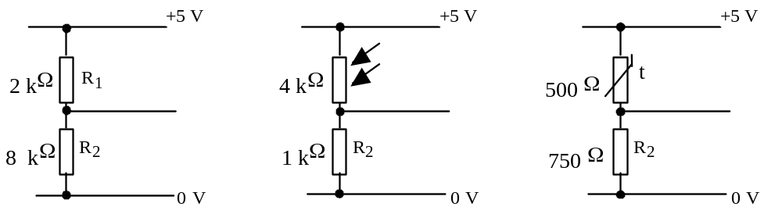

21. Calculate the p.d. across AB (voltmeter reading) in each of the following circuits.

B
B
+12
V
0
V
3 kΩ
3 kΩ
V
9 kΩ
3 kΩ
A
+10 V
0
V
3 kΩ
2 kΩ
V
6 kΩ
4 kΩ
A
B
+5 V
0
V
5 kΩ
2 kΩ
V
10 kΩ
8 kΩ
A
(a)
(b)
(c)

22. A circuit consisting of two potential dividers is set up as shown.

+9 V
0 V
6 kΩ
3 kΩ
V
9 kΩ
6 kΩ
A
B

(a) Calculate the reading on the voltmeter.
(b) (i) Suggest a value of a resistor to replace the 9 kΩ resistor that would give a reading of 0 V on the voltmeter.
(ii) Suggest a value of resistor to replace the 3 kΩ resistor that would give a reading of 0 V on the voltmeter.

23. In the circuits shown the reading on the voltmeters is zero. Calculate the value of the unknown resistors X and Y in each of the circuits.
12 V
12 V

120 Ω
4 kΩ
15 kΩ
X

V
V

Y
9 Ω
120 Ω
12 kΩ

Exercise 3: Electrical sources and internal resistance

- State what is meant by:

(a) the e.m.f. of a cell
(b) the p.d. between two points in a circuit.

2. A circuit is set up as shown.
3

Ω

X

Y
A

1

A

2

12

Ω

4

Ω

12 V

(a) Calculate the total resistance of the circuit.
(b) Calculate the readings on the ammeters.
(c) What is the value of the p.d. between X and Y?
(d) Calculate the power supplied by the battery.

3. The circuit shown uses a 230 V alternating mains supply.

12
Ω

8

Ω

24

Ω

S

230 V

Calculate the current in each resistor when:

(a) switch S is open
(b) switch S is closed.¶

4. An electric cooker has two settings, high and low. This involves two heating elements, R₁ and R₂. On the low setting the current from the supply is 1 A. On the high setting the current from the supply is 3 A.

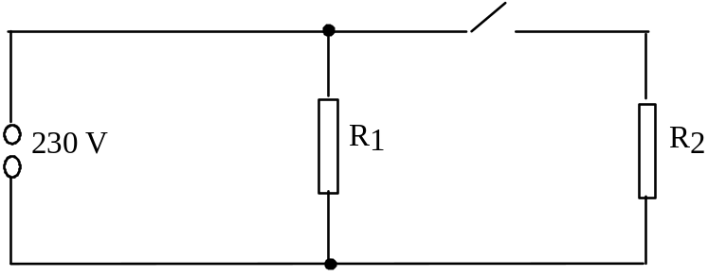

(a) Calculate the resistance of R₁ and R₂.
(b) What is the power consumption at each setting?
5. A lamp is rated at 12 V, 36 W. It is connected in a circuit as shown.

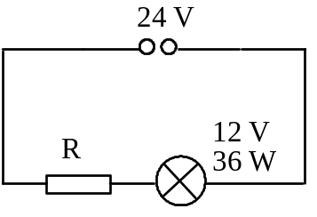
(a) Calculate the value of the resistor R that allows the lamp to operate at its normal rating.
(b) Calculate the power dissipated in the resistor.

- In the circuit shown, r represents the internal resistance of the cell and R represents the external resistance (or load resistance) of the circuit.

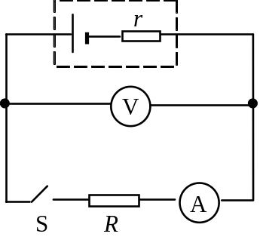
When S is open, the reading on the voltmeter is 2 0 V.
When S is closed, the reading on the voltmeter is 1 6 V and the reading on the ammeter is 0 8 A.

(a) What is the value of the e.m.f. of the cell?
(b) When S is closed what is the terminal potential difference across the cell?
(c) Calculate the values of r and R.
(d) The resistance R is now halved in value. Calculate the new readings on the ammeter and voltmeter.

- The battery in the circuit shown has an e.m.f. of 5 0 V.

V
r
A

The current in the lamp is 0 20 A and the reading on the voltmeter is 3 0 V. Calculate the internal resistance of the battery.
- A battery of e.m.f. 4 0 V is connected to a load resistor with a resistance of 15 Ω. There is a current of 0 2 A in the load resistor.
Calculate the internal resistance of the battery.

- A signal generator has an e.m.f. of 8 0 V and an internal resistance of 4 0 Ω. A load resistor is connected across the terminals of the generator. The current in the load resistor is 0 50 A. Calculate the resistance of the load resistor.

- A cell is connected in a circuit as shown below.

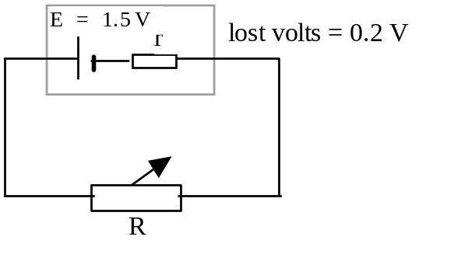

(a) Calculate the terminal p.d. across the cell.
(b) The resistance of the variable resistor R is now increased.

(i) Describe and explain what happens to the current in the circuit.
(ii) Describe and explain what happens to the p.d. across the terminals of the cell.

- A cell has an e.m.f. 1·5 V and an internal resistance of 2·0 Ω. A 3·0 Ω resistor is connected across the terminals of the cell. Calculate the current in the circuit.

- A student is given a voltmeter and a torch battery. When the voltmeter is connected across the terminals of the battery the reading on the voltmeter is 4·5 V.
When the battery is connected across a 6·0 Ω resistor the reading on the voltmeter decreases to 3·0 V.

(a) Calculate the internal resistance of the battery.
(b) What value of resistor when connected across the battery reduces the reading on the voltmeter to 2·5 V?

- In the circuit shown, the battery has an e.m.f. of 6·0 V and an internal resistance of 1·0 Ω.

R
S
V
r
A
6 V
1 Ω

When the switch is closed, the reading on the ammeter is 2·0 A.
What is the corresponding reading on the voltmeter?

- To find the internal resistance of a cell a load resistor is connected across the terminals of the cell. A voltmeter is used to measure V_{t.p.d,}, the voltage measured across the terminals of the cell. An ammeter is used to measure I, the current in the variable resistor. The table below shows the results obtained as the resistance of the variable resistor is changed.

V_{t.p.d}. (V) | 1·02 | 0·94 | 0·85 | 0·78 | 0·69 | 0·60
I (A) | 0·02 | 0·04 | 0·06 | 0·08 | 0·10 | 0·12

(a) Draw a diagram of the circuit used to produce these results.
(b) Plot a graph of the results and from it determine:
(i) the e.m.f. of the cell
(ii) the internal resistance of the cell
(iii) the short circuit current of the cell.

- A variable resistor is connected across a power supply. A voltmeter is used to measure V_{t.p.d.}, the voltage measured across the terminals of the supply. An ammeter is used to measure I, the current in the variable resistor. The table below shows the results obtained as the resistance of the variable resistor is changed.

V_{t.p.d.} (V) | 5·5 | 5·6 | 5·7 | 5·8 | 5·9
I (A) | 5·0 | 4·0 | 3·0 | 2·0 | 1·0

Plot a graph of V_{t.p.d}. against I.

(a) What is the value of the open circuit p.d.?
(b) Calculate the internal resistance of the power supply.
(c) Calculate the short circuit current of the power supply.
(d) The variable resistor is now removed from the circuit and a lamp of resistance 1·5 Ω is connected across the terminals of the supply.

Calculate:
(i) the terminal p.d.
(ii) the power delivered to the lamp.

16. A circuit is set up as shown to investigate the properties of a battery.

R
S
V
r
A
E

The variable resistor provides known values of resistance R.

For each value of resistance R, the switch is closed and the current I noted.
The table shows the results obtained.

R (Ω) | 0 | 2 | 4 | 6 | 8 | 10 | 12
I (A) | 6·80 | 3·78 | 2·62 | 2·00 | 1·62 | 1·36 | 1·17
1/I (A^{–1})

(a) Show that the relationship E = I(R + r) can be put in the form:

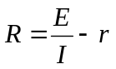

(b) Complete the third row in the table.

(c) Use the values of R and 1/I to plot a graph.

(d) Use the information in the graph to find:
(i) the internal resistance of the battery
(ii) the e.m.f. of the battery.¶

(e) The battery is now short circuited. Calculate the current in the battery when this happens.
17. A student uses the following circuit to investigate the conditions for transferring the maximum power into a load resistor.

R
S
V
r
A
12 V
4Ω

For each setting of the variable resistor the current in the circuit is recorded.
The table below shows the results obtained.

R (Ω) | 1 | 2 | 3 | 4 | 5 | 6
I (A) | 2·40 | 2·00 | 1·71 | 1·50 | 1·33 | 1·20
Power in R (W)

- Complete the table by calculating the power in the load for each value of R.
- Sketch a graph to show how the power in the load resistor R varies with R.
- In order to achieve maximum transfer of power, what is the relationship between the internal resistance of the power source and the resistance of the load resistor?

18. An automotive electrician needed to accurately measure the resistance of a resistor.
She set up a circuit using an analogue milliammeter and a digital voltmeter.

The two meter readings were as shown in the diagram below.

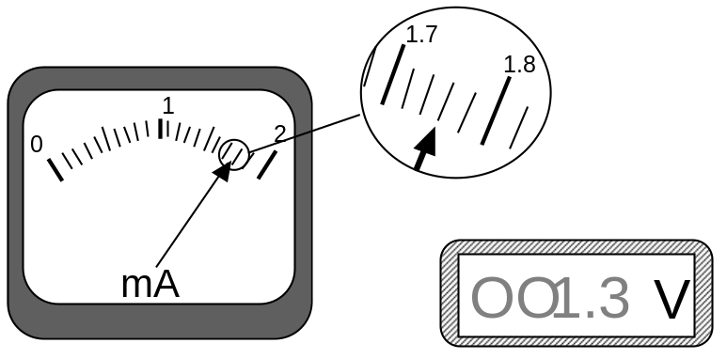

- What are the readings on the ammeter and the voltmeter?

- What is the nominal resistance calculated from these readings

- What is the smallest division on the milliammeter?

- What is the absolute uncertainty on the milliammeter?

- What is the absolute uncertainty on the voltmeter?

- What is the percentage uncertainty on the milliammeter?

- What is the percentage uncertainty on the voltmeter?

- Which is the greatest percentage uncertainty?

- What is the percentage uncertainty in the resistance?

- What is the absolute uncertainty in the resistance?

- Express the final result as (resistance ± uncertainty) Ω

(l) Round both the result and the uncertainty to the relevant number of significant figures or decimal places.

Exercise 4: Capacitors

1. A 50 µF capacitor is charged until the p.d. across it is 100 V.

(a) Calculate the charge on the capacitor when the p.d. across it is 100 V.
(b) (i) The capacitor is now ‘fully’ discharged in a time of 4·0 milliseconds. Calculate the average current during this time.
(ii) Why is this average current?

2. A capacitor stores a charge of 3·0 × 10^{–4} C when the p.d. across its terminals is 600 V.
What is the capacitance of the capacitor?

3. A 30 µF capacitor stores a charge of 12 × 10^{–4} C.
(a) What is the p.d. across its terminals?
(b) The tolerance of the capacitor is ± 0·5 µF. Express this uncertainty as a percentage.

4. A 15 µF capacitor is charged using a 1·5 V battery.
Calculate the charge stored on the capacitor when it is fully charged.

5. (a) A capacitor stores a charge of 1·2 × 10^{–5} C when there is a p.d. of 12 V across it. Calculate the capacitance of the capacitor.
(b) A 0·10 µF capacitor is connected to an 8·0 V d.c. supply. Calculate the charge stored on the capacitor when it is fully charged.

6. A circuit is set up as shown.
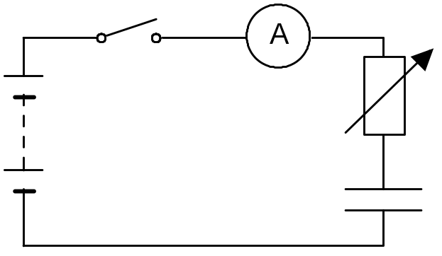

The capacitor is initially uncharged. The switch is now closed.
The capacitor is charged with a constant charging current of
2·0 × 10^{–5} A for 30 s.

At the end of this time the p.d. across the capacitor is 12 V.

(a) What has to be done to the value of the variable resistor in order to keep the current constant for 20 s?
(b) Calculate the capacitance of the capacitor.
7. A 100 µF capacitor is charged using a 20 V supply.

(a) How much charge is stored on the capacitor when it is fully charged?
(b) Calculate the energy is stored in the capacitor when it is fully charged.

8. A 30 µF capacitor stores 6·0 × 10^{–3} C of charge. How much energy is stored in the capacitor?

- The circuit below is used to investigate the charging of a capacitor.

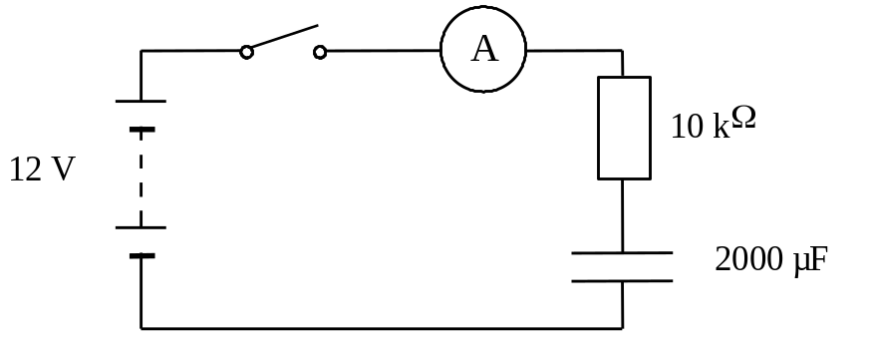

The battery has negligible internal resistance.
The capacitor is initially uncharged. The switch is now closed.

(a) Describe what happens to the reading on the ammeter from the instant the switch is closed.
(b) How can you tell when the capacitor is fully charged?
(c) What would be a suitable range for the ammeter?
(d) The 10 k Ω resistor is now replaced by a larger resistor and the investigation repeated.
What is the maximum voltage across the capacitor now?

- In the circuit below the neon lamp flashes at regular intervals.

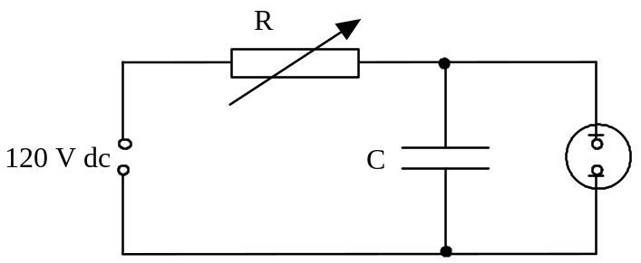

The neon lamp requires a potential difference of 100 V across it before it conducts and flashes. It continues to glow until the potential difference across it drops to 80 V. While lit, its resistance is very small compared with the resistance of R.
(a) Explain why the neon bulb flashes.
(b) Suggest two methods of decreasing the flash rate.

11. In the circuit below the capacitor C is initially uncharged.

9 V
C
A
V
S
+
–

Switch S is now closed. By carefully adjusting the variable resistor R a constant charging current of 1·0 mA is maintained.
The reading on the voltmeter is recorded every 10 seconds. The results are shown in the table below.

Time (s) | 0 | 10 | 20 | 30 | 40
V (V) | 0 | 1·9 | 4·0 | 6·2 | 8·1

(a) Plot a graph of the charge on the capacitor against the p.d. across the capacitor.
(b) Use the graph to calculate the capacitance of the capacitor.

12. The circuit below is used to charge and discharge a capacitor.
100 V
V_{R}
V_{C}
1
2
A
B
The battery has negligible internal resistance.
The capacitor is initially uncharged.
V_{R} is the p.d. across the resistor and V_{C} is the p.d. across the capacitor.

(a) What is the position of the switch:
(i) to charge the capacitor
(ii) to discharge the capacitor?

(b) Sketch graphs of V_{R} against time for the capacitor charging and discharging. Show numerical values for the maximum and minimum values of V_{R}.

(c) Sketch graphs of V_{C} against time for the capacitor charging and discharging. Show numerical values for the maximum and minimum values of V_{C}.

(d) (i) When the capacitor is charging what is the direction of the electrons between points A and B in the wire?
(ii) When the capacitor is discharging what is the direction of the electrons between points A and B in the wire?

(e) The capacitor has a capacitance of 4·0 µF. The resistor has resistance of 2·5 MΩ.

Calculate:
(i) the maximum value of the charging current
(ii) the charge stored by the capacitor when the capacitor is fully charged.

13. A capacitor is connected in a circuit as shown.

3 V
+
–
3 MΩ
3 μF
S

The power supply has negligible internal resistance. The capacitor is initially uncharged.
V_{R} is the p.d. across the resistor and V_{C} is the p.d. across the capacitor.
The switch S is now closed.

(a) Sketch graphs of:
(i) V_{C} against time during charging. Show numerical values for the maximum and minimum values of V_{C}.
(ii) V_{R} against time during charging. Show numerical values for the maximum and minimum values of V_{R}.
- (i) What is the p.d. across the capacitor when it is fully charged?
(ii) Calculate the charge stored by the capacitor when it is fully charged.
- Calculate the maximum energy stored by the capacitor.

14. A capacitor is connected in a circuit as shown.

12 V
+
–
6 kΩ
20 μF
S

The power supply has negligible internal resistance.
The capacitor is initially uncharged. The switch S is now closed.

(a) Calculate the value of the initial current in the circuit.
(b) At a certain instant in time during charging the p.d. across the capacitor is 3 V. Calculate the current in the resistor at this time.

15. The circuit shown is used to charge a capacitor.

12 V
+
–
5 kΩ
10 μF
S

The power supply has negligible internal resistance.
The capacitor is initially uncharged. The switch S is now closed.
At a certain instant in time the charge on the capacitor is 20 µC.
Calculate the current in the circuit at this time.

16. The circuit shown is used to investigate the charge and discharge of a capacitor.
12 V
V_{R}
V_{C}
2
1
1 kΩ
10 mF
A

The switch is in position 1 and the capacitor is uncharged.
The switch is now moved to position 2 and the capacitor charges.
The graphs show how V_{C}, the p.d. across the capacitor, V_{R}, the p.d. across the resistor, and I, the current in the circuit, vary with time.

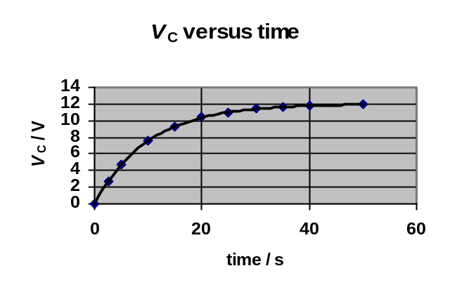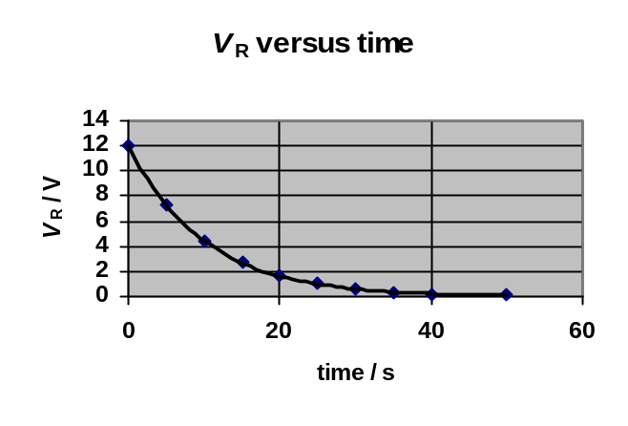

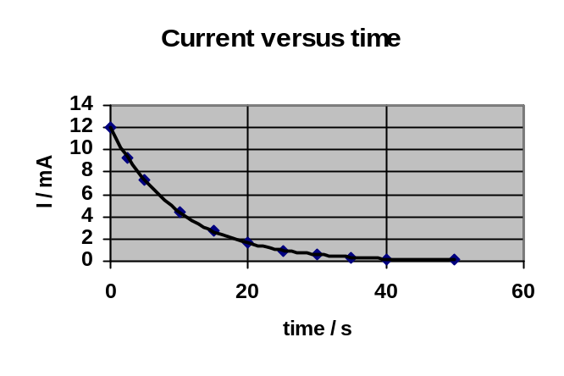

(a) The experiment is repeated with the resistance changed to 2 kΩ.
Sketch the graphs above and on each graph sketch the new lines which show how V_{C}, V_{R} and I vary with time.
(b) The experiment is repeated with the resistance again at 1 kΩ but the capacitor replaced with one of capacitance 20 mF. Sketch the original graphs again and on each graph sketch the new lines which show how V_{C}, V_{R} and I vary with time.
(c) (i) What does the area under the current against time graph represent?
(ii) Compare the areas under the current versus time graphs in the original graphs and in your answers to (a) and (b). Give reasons for any differences in these areas.
(d) At any instant in time during the charging what should be the value of (V_{C} + V_{R}) ?
(e) The original values of resistance and capacitance are now used again and the capacitor fully charged. The switch is now moved to position 1 and the capacitor discharges.
Sketch graphs of V_{C}, V_{R} and I from the instant the switch is moved until the capacitor is fully discharged.
17. A student uses the circuit shown to investigate the charging of a capacitor.

12 V
+
–
1 kΩ
10 μF
S

The capacitor is initially uncharged.
The student makes the following statements:

(a) When switch S is closed the initial current in the circuit does not depend on the internal resistance of the power supply.
(b) When the capacitor has been fully charged the p.d. across the capacitor does not depend on the internal resistance of the power supply.

Use your knowledge of capacitors to comment on the truth or otherwise of these two statements.

Exercise 5: Electrons at work

1. In the following descriptions of energy levels in metals, insulators and semiconductors some words and phrases have been replaced by the letters A to N.

In a metal the ____A____ band is completely filled and the ____B____ band is partially filled. The electrons in the ____C____ band are free to move under the action of ____D____ so the metal has a ____E____ conductivity.

In an insulator there are no free electrons in the ____F____ band. The energy gap between the two bands is large and there is not enough energy at room temperature to move electrons from the ____G____ band into the ____H____ band.
Insulators have a very ____I____ conductivity.

In a pure semiconductor the energy gap between the valence and conduction bands is ____J____ than in a metal. At room temperature there is enough energy to move some electrons from the ____K____ band into the ____L____ band. As the temperature is increased the number of electrons in the conduction band ____M____ so the conductivity of the semiconductor ____N____.

From the table below choose the correct words or phrases to replace the letters.

Letter | List of replacement word or phrase
A, B, C, F, G, H, K, L | conduction, valence
D | an electric field, a magnetic field
E, I | low, high
J | bigger, smaller
M, N | decreases, increases

2. The conductivity of a semiconductor material can be increased by ‘doping’.

(a) Explain what is meant by the ‘conductivity’ of a material.
(b) Explain, giving an example, what is meant by ‘doping’ a semiconductor.
(c) Why does ‘doping’ decrease the resistance of a semiconductor material?
3. (a) A sample of pure germanium (four electrons in the outer shell) is doped with phosphorus (five electrons in the outer shell). What kind of semiconductor is formed?
(b) Why does a sample of n-type semiconductor still have a neutral overall charge?

4. Describe the movement of the majority charge carriers when a current flows in:

- an n-type semiconductor material
- a p-type semiconductor material.

5. A p-n junction diode is connected across a d.c. supply as shown.

- Is the diode connected in forward or reverse bias mode?
- Describe the movement of the majority charge carriers across the p-n junction.
- What kind of charge is the only one that actually moves across the junction?

6. When positive and negative charge carriers recombine at the junction of ordinary diodes and LEDs, quanta of radiation are emitted from the junction.

- Does the junction have to be forward biased or reverse biased for radiation to be emitted?
- What form does this emitted energy take when emitted by:
- an LED
- an ordinary junction diode?

7. A particular LED is measured as having a recombination energy of 3·12 × 10^{–19} J.

(a) Calculate the wavelength of the light emitted by the LED.
(b) What colour of light is emitted by the LED?
(c) What factor about the construction of the LED determines the colour of the emitted light?

8. (a) State two advantages of an LED over an ordinary filament lamp.
(b) An LED is rated as follows: operating p.d. 1·8 V, forward current 20 mA

The LED is to be operated from a 6 V d.c. power supply.

- Draw a diagram of the circuit, including a protective resistor, which allows the LED to operate at its rated voltage.
- Calculate the resistance of the protective resistor that allows the LED to operate at its rated voltage.

9. The diagram shows a photodiode connected to a voltmeter.

- In which mode is the photodiode operating?
- Light is now incident on the photodiode.
(i) Explain how an e.m.f. is created across the photodiode.
(ii) The irradiance of the light incident on the photodiode is now increased. Explain why this increases the e.m.f. of the photodiode.

10. A photodiode is connected in reverse bias in a series circuit as shown.

(a) In which mode is the photodiode is operating?
(b) Why is the photodiode connected in reverse bias?
(c) What is the current in the circuit when the photodiode is in darkness? Explain your answer.
(d) The irradiance of the light on the photodiode is now increased.
(i) What is the effect on the current in the circuit?
(ii) What happens to the effective ‘resistance’ of the photodiode? Explain why this happens.

Formal Homework 1: Monitoring and Measuring a.c &
Current, voltage, power and resistance

- A signal from a power supply is displayed on an oscilloscope. The trace on the oscilloscope is shown.
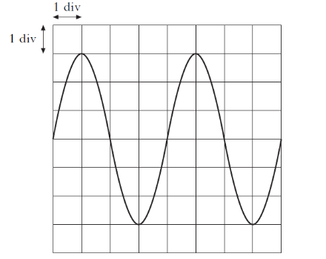

The time-base is set at 0.01s/div and the y-gain is set at 4.0 V/div.
Which row in the table shows the r.m.s voltage and the frequency of the signal?

 | r.m.s voltage (V) | Frequency (Hz)
A | 8.5 | 25
B | 12 | 25
C | 24 | 25
D | 8.5 | 50
E | 12 | 50
(1)

- The output of a 50Hz a.c. supply is connected to the input of an oscilloscope. The trace produced on the screen of the oscilloscope is shown.

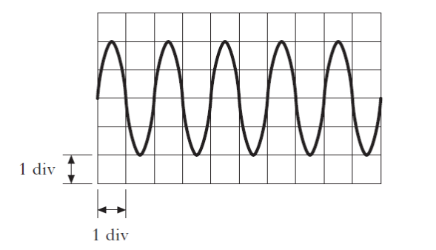
The time-base control of the oscilloscope is set at

A 1ms/div
B 10ms/div
C 20ms/div
D 100ms/div
E 200ms/div (1)

- A student writes the following statements about electric fields

I There is a force on a charge in an electric field.
II When an electric field is applied to a conductor, the free electric charges in the conductor move.
III Work is done when a charge is moved in an electric field.

Which of the statements is/are correct?

A I only
B II only
C I and II only
D I and III only
E I, II and III (1)

- Four resistors, each of resistance 20 Ω, are connected to a 60 V supply of negligible internal resistance, as shown.
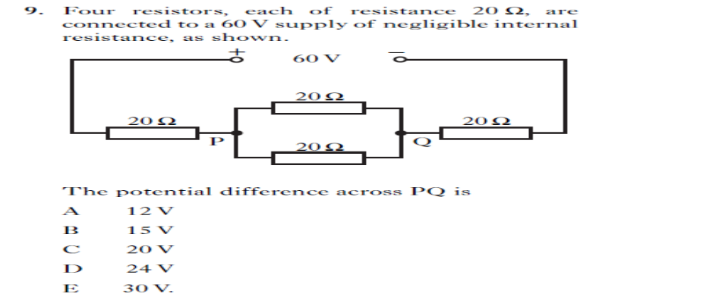

The potential difference across PQ is

A 12 V
B 15 V
C 20 V
D 24 V
E 30 V (1)

- A circuit consisting of two voltage dividers is set up as shown below.
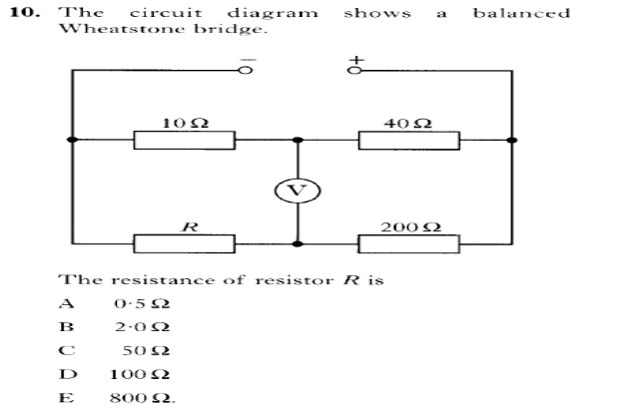
The reading on the voltmeter is 0 V.

The resistance of the resistor R is

A 0.5 Ω
B 2.0 Ω
C 50 Ω
D 100 Ω
E 800 Ω (1)

- The circuit shown is used to compare the voltage from a battery and the voltage produced by a signal generator.

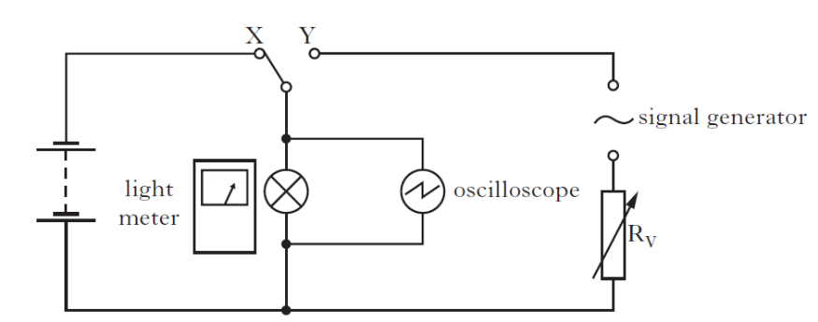

The switch is connected to X and the voltage across the lamp is 2.30 V. the reading on the light meter is recorded. The switch is now connected to Y. The resistance of R_{V} is adjusted until the light meter reading is the same as before.

The trace on the oscilloscope screen is shown.
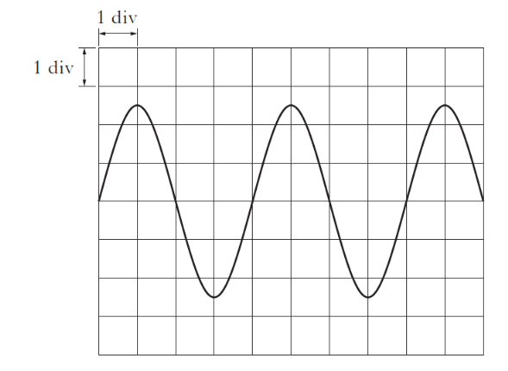
- The time-base setting is 0.01s/div.

Calculate the frequency of the output voltage of the signal generator. (3)

- Calculate the peak value of the voltage displayed on the oscilloscope. (3)

- With the switch still connected to Y, the signal generator frequency is now doubled without altering the output voltage.

State what happens to the reading on the light meter.

Justify your answer. (1)
- This simple circuit uses an LDR to switch on a lamp at night.
The resistance of an LDR under different light conditions is shown in the table

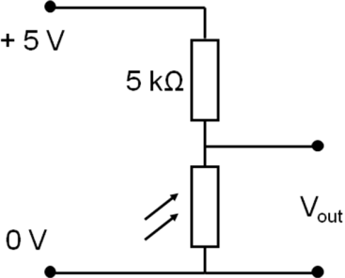
Condition | Resistance
Light | 100 Ω
Dark | 20 kΩ

Calculate the output voltage of the LDR when it is (a) in the dark and (b) in the light (4)

- A technician builds a circuit containing a resistor and a motor as shown below.
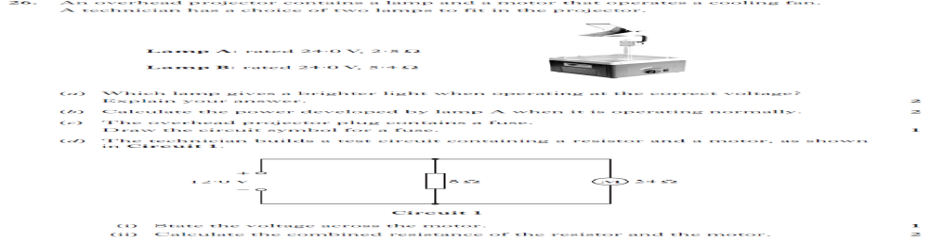

(a) What is the voltage across the motor (1)

(b) Calculate the power developed in the motor. (3)

Total 20

Formal Homework 2: Electrical Sources and Internal resistance & Capacitors

1. A student writes the following statements about a circuit.

I The power supply is equivalent to a source of e.m.f. with a resistor in parallel, the internal resistance.

II The e.m.f. of a source is equal to the open circuit p.d. across the terminals of a source.

III The closed circuit p.d. across the terminals of a source is equal to the t.p.d.

Which of the following statements is/are correct?
A I only
B II only
C I and II only
D II and III only
E I, II and III
(1)

2. A battery of e.m.f. 12 V and internal resistance 3.0 Ω is connected in a circuit as shown

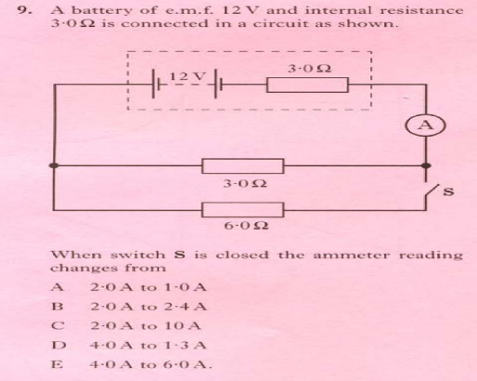

When switch S is closed the ammeter reading changes from

A 2.0 A to 1.0 A
B 2.0 A to 2.4 A
C 2.0 A to 10 A
D 4.0 A to 1.3 A
E 4.0 A to 6.0 A (1)

3. A circuit is set up as shown

The variable resistor R is adjusted and a series of readings taken from the voltmeter and ammeter.
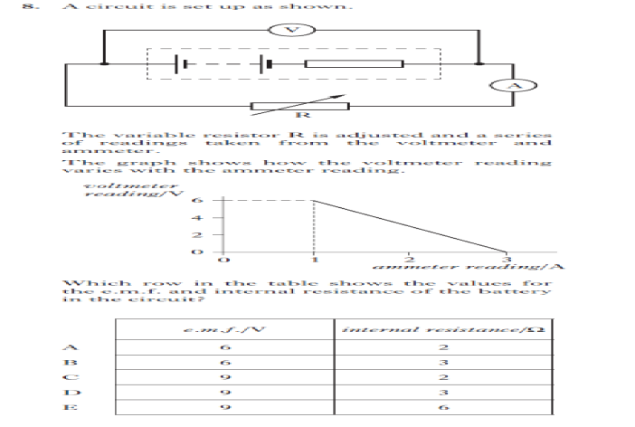

The graph shows how the voltmeter reading varies with the ammeter reading.

Which row in the table shows the values for the e.m.f. and internal resistance of the battery in the circuit?

(1)

4. A 25µF capacitor is charged until the potential difference across it is 500V.

The charge stored in the capacitor is

A 5.00 x 10⁻⁸ C
B 2.00 x 10⁻⁵C
C 1.25 x 10⁻²C
D 1.25 x 10⁴ C
E 2.00 x 10⁷C (1)

5. A student makes the following statements about capacitors.

I Capacitors block a.c. signals.
II Capacitors store energy.
III Capacitors store charge.

Which of these statements is/are true?

A I only
B I and II only
C I and III only
D II and III only
E I, II and III (1)

6. A circuit is set up as shown.
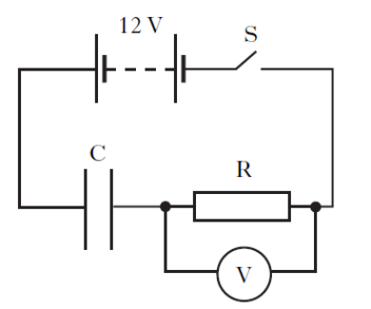
The capacitor is initially uncharged.
Switch S is now closed. Which graph shows how the potential difference, V across R, varies with time, t?

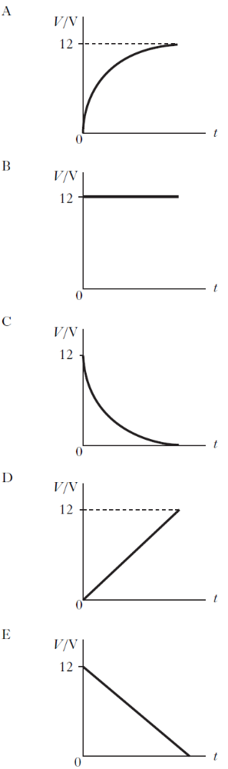 (1)

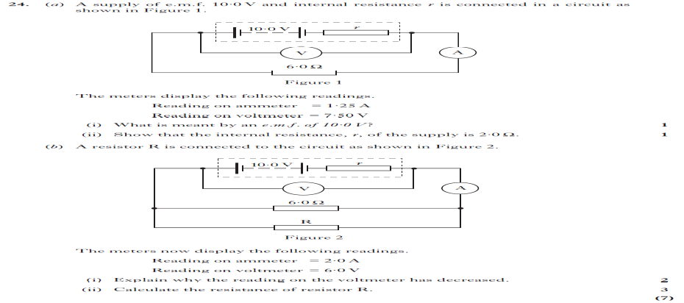
- (a) A supply of e.m.f. 10.0 V and internal resistance r is connected in a circuit as shown in Figure 1.

The meters display the following readings
Reading on ammeter = 1.25 V
Reading on voltmeter = 7.50 V

- What is meant by an e.m.f. of 10.0 V? (1)

- Show that the internal resistance, r, of the supply is 2.0 Ω (2)

(b) A resistor R is connected to the circuit as shown in Figure 2.

The meters now display the following readings.
Reading on ammeter = 2.0 V
Reading on voltmeter = 6.0 V

- Explain why the reading on the voltmeter has decreased (2)
- If the total resistance across the resistors in parallel is 3.0 Ω, calculate the resistance of resistor R (3)

8. (a) State what is meant by the term capacitance. (1)

(b) An uncharged capacitor, C is connected in a circuit as shown.
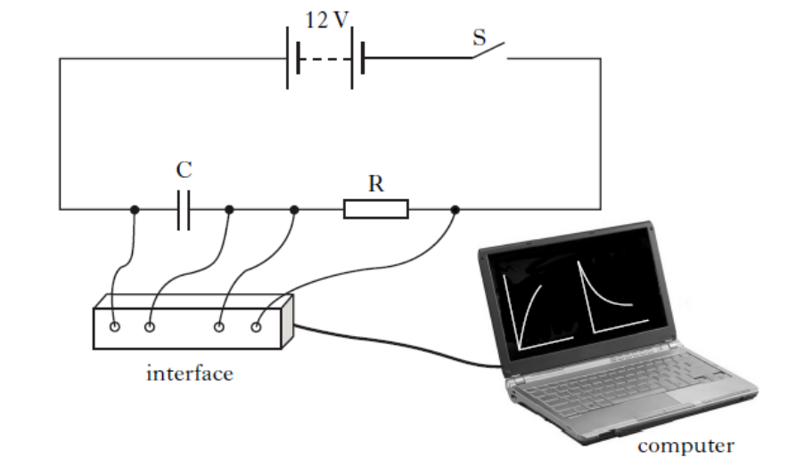
The 12V battery has negligible internal resistance.

Switch S is closed and the capacitor begins to charge.

The interface measures the current in the circuit and the potential difference (p.d) across the capacitor. These measurements are displayed as graphs on the computer.

Graph 1 shows the p.d. across the capacitor for the first 0.40s of charging.
Graph 2 shows the current in the circuit for the first 0.40s of charging.

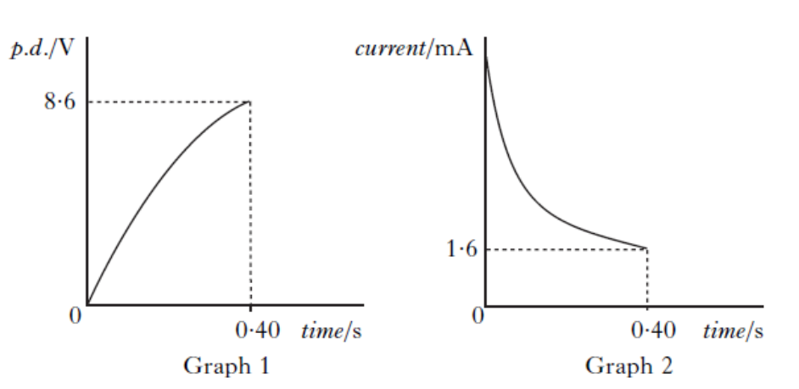

- Determine the p.d. across resistor R at 0.40s. (1)
- Calculate the resistance of R. (3)
- The capacitor takes 2.2 seconds to charge fully.
At that time it stores 10.8mJ of energy.
Calculate the capacitance of the capacitor. (4)
(c) The capacitor is now discharged.
A second, identical resistor is connected in the circuit as shown.

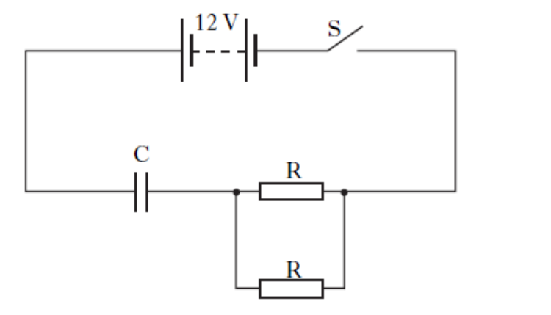

Switch S is closed.
Is the time taken for the capacitor to fully charge less than, equal to, or greater than the time taken to fully charge in part (b)?

Justify your answer. (2)

Total 25

Formal Homework 3: Electrons at work

- The letters X, Y and Z represent three missing words from the following passage.

Materials can be divided into three broad categories according to their electrical resistance.

……….X………. have a very high resistance.

……….Y………. have a high resistance in their pure form but when small amounts of certain impurities are added, the resistance decreases.

……….Z………. have a low resistance.

Which row in the table shows the missing words?

 | X | Y | Z
A | conductors | insulators | semi-conductors
B | semi-conductors | insulators | conductors
C | insulators | semi-conductors | conductors
D | conductors | semi-conductors | insulators
E | insulators | conductors | semi-conductors
1

2. In a n-type semiconductor

A the majority charge carriers are electrons

B the majority charge carriers are holes

C the majority charge carriers are protons

D there are more protons than electrons

E there are more electrons than protons
1

3. A student writes the following statements about p-type semiconductor material.

I Most charge carriers are positive.
II The p-type material has a positive charge.
III Impurity atoms in the material have 3 outer electrons.

Which of these statements is/are correct?

A I only
B II only
C I and II only
D I and III only
E I, II and III
1

4. A student writes down the following statements about a semiconductor.

I A semiconductor allows a small current to flow when a potential difference is applied across it.
II The conductivity of a semiconductor can be increased by adding impurities
III The resistance of a semiconductor is increased by raising the temperature

Which of these statements is/are correct?
A I only
B II only
C I and II only
D I and III only
E I, II and III 1

5. A p-n junction diode is forward biased.
Positive and negative charge carriers recombine in the junction region. This causes the emission of

A a hole
B an electron
C an electron-hole pair
D a proton
E a photon 1

- A student is reading the following passage in a physics dictionary.

“……is a solid state device in which positive and negative charge carriers are produced
by the action of light on a p-n junction.”

The passage describes

A a thermistor
B a MOSFET
C a photodiode
D a laser
E an LED
1

- In the following circuit, component X is used to drive a motor.
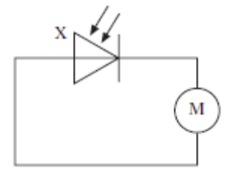
Which of the following gives the name of component X and its mode of operation?

 | Name of component X | Mode of operation
A | Light emitting diode | photoconductive
B | Light emitting diode | photovoltaic
C | Photodiode | photoconductive
D | Photodiode | photovoltaic
E | Op-amp | inverting
1
(7)

8. The electrical conductivity of solids can be explained by band theory.

The diagrams below show the distributions of the valence and conduction bands of materials classified as conductors, semiconductors and insulators.

Shaded areas represent bands occupied by electrons.

The band gap is also indicated.
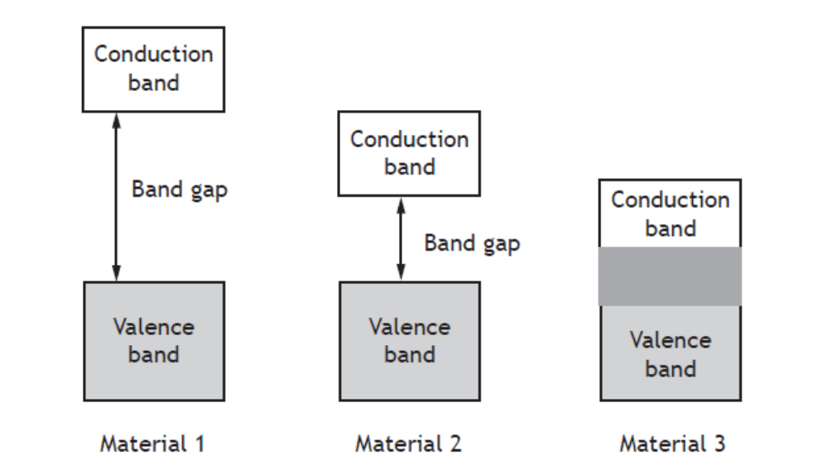

(a) State which of the above materials is a conductor, a semiconductor and an insulator. 1

(b) Explain the difference between insulators and conductors in terms of the energy bands. 2

(c) With reference to the energy bands, explain how and why the conductivity of a semiconductor depends on temperature. 2
(5)

9. The addition of impurities to semiconductor materials can result in n-type or p-type semiconductors.

(a) Name two impurities that when added to silicon makes it n-type material 1

(b) How many outer electrons does each of these elements contain. 1
(c) Name two impurities that when added to silicon makes it p-type material. 1

(d) How many electrons are in the outer shell of each of these elements. 1
(e) What is the name given to the process of adding impurities to these semiconductors? 1
(5)

10. A p-n junction is used as a photodiode as shown.

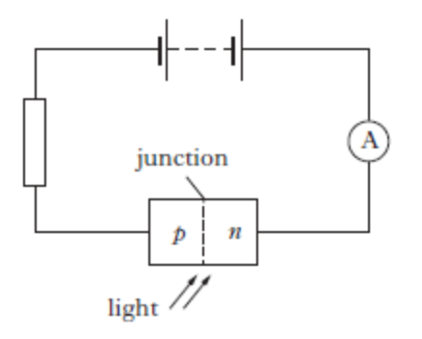

- In which mode is the photodiode operating? 1

- The irradiance of light on the junction of the photodiode is now increased.

Explain what happens to the current in the circuit. 2
(3)

11. The brake lights of a car consist of a number of very bright LED’s.

An LED from the brake lights is forward biased by connecting it to a 12V car battery as shown.

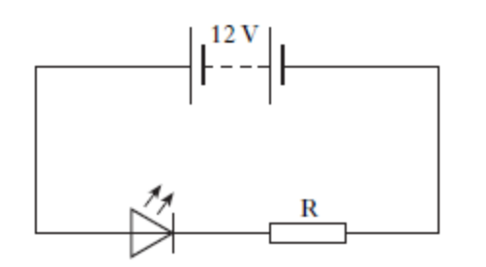

The battery has negligible internal resistance.

- Explain, in terms of charge carriers, how the LED emits light. 1

- The LED is operating at its rated values of 5.0V and 2.2W.

Calculate the value of resistor R. 4
(5)

Total 25

Solutions

Exercise 1: Monitoring and measuΩring a.c.

1. (a) 325 V
(b) 100 times

2 (c) V_{r.m.s} . = 0.71 V_{peak}

3. (a) 14 V

4. (a) 8.5 V
(b) (i) 60 V
(ii) 42 V

5. (a) (i) 100 Hz
(ii) ±2 Hz

6. 5 cm

Exercise 2: Current, voltage, power and resistance

1. 0.64 C

2. 5 × 10³ A

3. 2·0 × 10⁴ s

4. 6 V

5. (a) I = 0·1 A
(b) I = 0·5 A, V = 4·5 V
(c) I = 2 A, V = 10 V

6. (a) 5 Ω
(b) 6 Ω

7. (a) 25 Ω
(b) 25 Ω
(c) 24·2 Ω
(d) 13·3 Ω
(e) 22·9 Ω
(f) 14·7 Ω.

8. 3·75 × 10^{–3} V

9. (a) 60 W
(b) 327 W
(c) 500 W

10. (a) 7·7 A
(b) 1763 W

11. 9000 J

12. I = 0·67 A, V = 4 V

13. (a) 0·67 A
(b) 0·13 A
(c) 1·34 V

14. 240 Ω
15. (c) 175 Ω

18. (a) V₁ = 0·2 V, V₂ = 9·8 V
(b) V₁ = 2·5 V, V₂ = 7·5 V

20. (a) 4 V
(b) 1 V
(c) 3 V

21. (a) 3 V
(b) -0·8 V
(c) 0 V

22. (a) 0·6 V
(b) (i) 12 kΩ
(ii) 4 kΩ

23. X = 9 Ω Y = 45 Ω

Exercise 3: Electrical sources and internal resistance

2. (a) 6 Ω
(b) A₁ = 2 A, A₂ = 1·5 A
(c) 6 V
(d) 24 W

3. (a) In 12 Ω current is 11·5 A; in 24 Ω current is 0 A
(b) In 12 Ω current is 12·8 A; in 8 Ω current is 3·2 A; in 24 Ω current is 9·6 A

4. (a) R₁ = 230 Ω R₂ = 115 Ω
(b) Low 230 Ω high 690 Ω

5. (a) 4 Ω
(b) 36 W

6. (a) 2·0 V
(b) 1·6 V
(c) r = 0·5 Ω R = 2 Ω
(d) 1·3 A, 1·3 V

7. 10 Ω

8. 5 Ω

9. 12 Ω

10. (a) 1·3 V

11. 0·30 A

12. (a) 3·0 Ω
(b) 3·75 Ω

13. 4·0 V

14. (b) (i) 1·1 V, the intercept on the y-axis
(ii) 4·2 Ω the gradient of the line
(iii) 0·26 A

15 (a) 6 V
(b) 0·1 Ω
(c) 60 A
(d) (i) 5·6 V
(ii) 21 W

16. (b) 0·147, 0·264,0·382, 0·.500, 0·617, 0·735, 0·855
(d) (i) 2·5 Ω
(ii) 17 V
(e) 6·8 A

18. (a) Ammeter 1·76 mA, voltmeter 1·3 V
(b) 740 Ω
(c) 0·02 mA
(d) ±0·01 mA
(e) ± 0 1 V
(f) 0·6 %
(g) 8%
(h) 8%
(i) 8%
(j) 59 
(k) (740± 59) Ω
(l) (740± 60) Ω

Exercise 4: Capacitors

1. (a) 5·0 × 10^{–3} C
(b) (i) 1·25 A

2. 0·5 μF

3 (a) 40 V
(b) 1·7%

4. 2·25 × 10^{–5} C

5. (a) 1·0 μF
(b) 0·8 μC

6. (b) 50 μF

7. (a) 2·0 × 10^{–3} C
(b) 0·020 J

8. 0·60 J

9. (b) Reading on ammeter is 0 A
(c) 0 to 2 mA (max. current 1·2 mA)
(d) 12 V

11. (b) 4·9 mF

12. (e) (i) 40 μA
(ii) 4·0 × 10² μC

13. (b) (i) 3 V
(ii) 9 μC
(c) 1·35 × 10^{–5} J

14. (a) 2 mA
(b) 1·5 mA

15. 2 mA

Exercise 5: Electrons at work

1. A = valence; B = conduction; C = conduction; D = an electric field; E = high; F = conduction; G = valence; H = conduction; I = low; J = smaller; K = valence; L = conduction; M = increases; N = increases.

7. (a) 638 nm
(b) Red

8. (b) (ii) 210 Ω
Formal Homework 1: Marking Scheme

- A
- B
- E
- A
- C (5)

- (a) Total time =nos. of divisions x time base setting
= 10 x 0.01
= 0.1 (s)

f = number of waves
total time
f = 2.5
0.1
f = 25Hz (3)

(b) V_{p} = √2 x V_{rms}
= √2 x 2.30
= 3.25 V (3)
- Stays constant/no change/nothing happens,
- Current is independent of frequency. (both) (1)

- (a) V_{out} = (R₁/ R₁+ R₂) x V_{S} (1)
= 5,000 (5,000 + 20,000) x 5 (1)
= 1.0 V (1)

(b) V_{out} = 4.9 V (1)

- (a) 12 V (1)

(b) P = V²/R (1) = 12²/ 24
= 6 W (1)

Total 20

Formal Homework 2: Marking Scheme

- D (1)
- B (1)
- D (1)
- C (1)
- D (1)
- C (1)

- (a) (i) 10 J of energy are given to each Coulomb of charge passing through the supply (1)
(ii) I = E / (R + r) (1)
1.25 = 10 / (6 + r) (1)
R = 2.0 Ω

(b) (i) (Total) resistance decreases (1)
(Circuit) current increases

Lost volts increases (1)
(ii) 1/R_{T} = 1/R₁ + 1/R₂ (1) 1/3 = 1/6 + 1/R (1) R = 6.0 Ω (1)

- (a) Coulombs per volt (1)

(b) (i) 12 – 8.6 = 3.4 V (1)

(ii) R = V/ I
R = 3.4 / 0.0016
R = 2125 Ω (3)

(iii) V = 12 V (1)
E = C V²
10.8 x 10⁻³ = x C x (12x12)
C = 0.00015F (3)

(c) Time is less (1)
Since resistance is less and flow of charge is greater (1)

Total 25

Formal Homework 3: Marking Scheme

- C
- A
- D
- C
- E
- C
- D
(7)

- a) Material 1 – insulator; Material 2 – semiconductor; Material 3 – conductor
(1)
b) In an insulator, the gap between the conduction and valence bands is large and there are no free electrons in the conduction band.
(1)
In a conductor, the conduction and valence bands cross over. Therefore electrons are free to move in a conductor. (1)
- In general, the conductivity of semiconductors increases as the temperature rises.
(1)
This is because the thermal energy allows more electrons to jump from the valence band to the conduction band. (1)

9. a) Phosphorous, arsenic and antimony (1)

b) 5 (1)

c) Boron, aluminium, gallium and indium (1)

d) 3 (1)

e) Doping (1)

10. (a) photoconductive (1)

(b) Current increases, since more photons of light arrive at the junction (1)
More charged carriers produced per second (1)

11. (a) electrons and holes recombine at the junction (1)

(b) V_{R} = 7 V (1)

I = P/ V = 2.2 / 5 = 0.44A (1)

R = V/I = 7 / 0.44 = 16Ω (2)

Total 25

